Job no:3

Job Name: Table tag

Input:

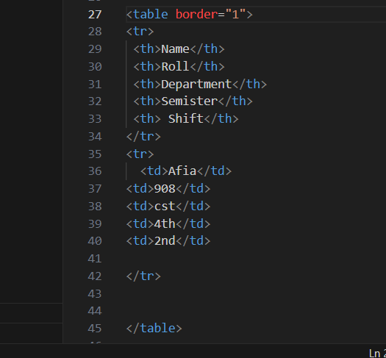

Output:

